Order Of Service

Singing: Psalm 150—CW page 122

Reading: Psalm 66

Opening Hymn: TLH 61

Reading: Acts 7:54-60

Request Hymn: CW Supplement 735

Reading: John 16:16-24

Sermon Hymn: TLH 325

Sermon Text: Daniel 2:14-18

Prayer For Mercies

Prayer

The Apostles’ Creed, TLH page 12

Holy Communion

The Lord's Prayer

The Blessing

Closing Hymn: TLH 64

* * * * * * * * * * *
Bible Study: Lambs: Penguin
Sheep: Romans 8:1-8
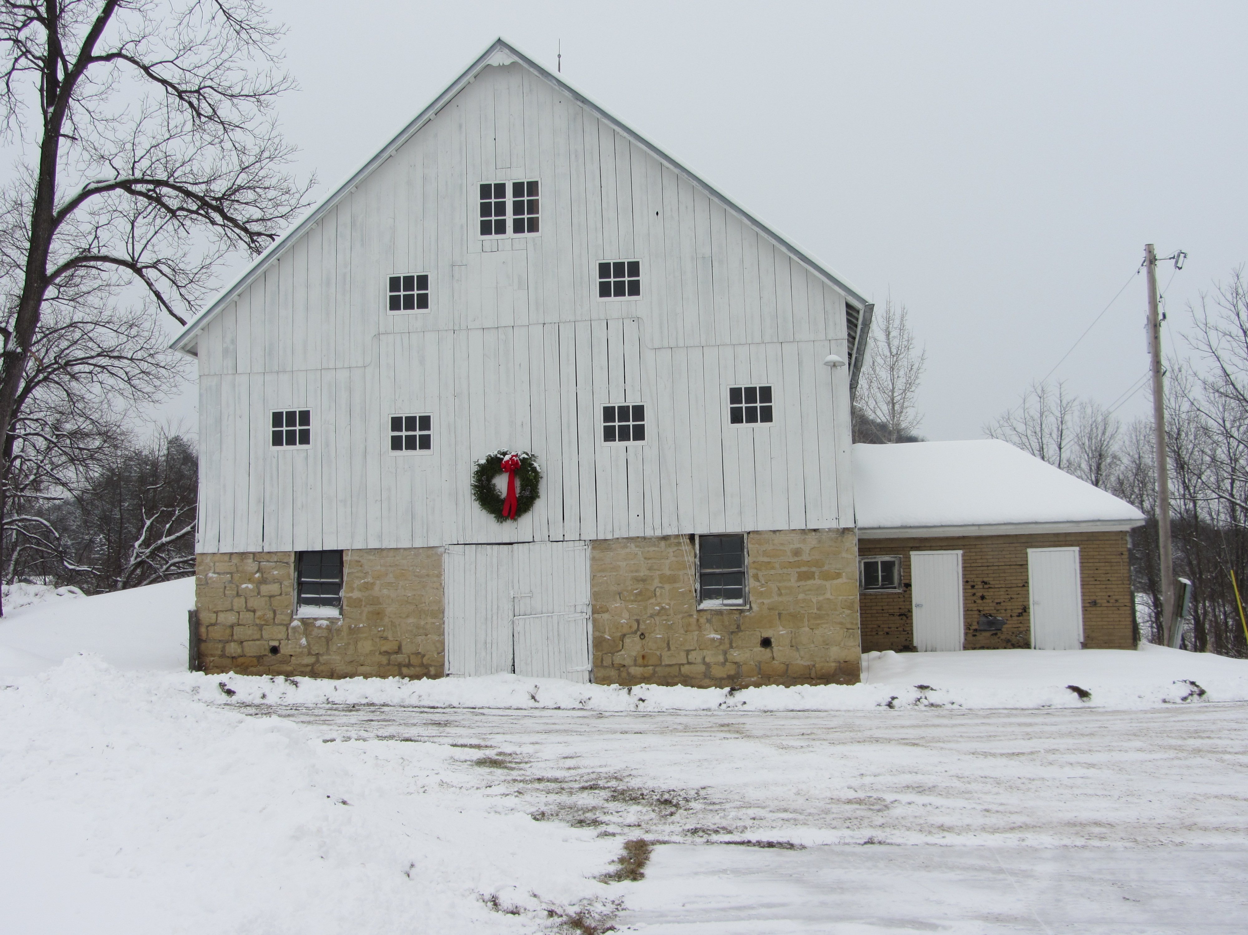

Winter At MGMF

Water
Of
Life

17 December 2017

W A T E R O F L I F E

Independent Christian Church—Conservative Lutheran Doctrine

Worship Service: 9:30 a.m. Bible Study: 10:45 a.m.

Larry Cooper, Pastor E-Mail address:
111 N. Ridge Road lcooper@wateroflife.cc
Coon Valley, WI 54623 Web Site:
Phone: (608) 452-2105 www.wateroflife.cc

* * * * * * * * * * * * * * * * * * * * * * * * * * *

Sermon Text: Daniel 2:14-18

Prayer For Mercies

* * * * * * * * * * * * * * * * * * * * * * * * * * *

Daniel 2:14 Then Daniel answered with counsel and wisdom to Arioch the captain of the king's guard, which was gone forth to slay the wise men of Babylon:
:15 He answered and said to Arioch the king's captain, Why is the decree so hasty from the king? Then Arioch made the thing known to Daniel.
:16 Then Daniel went in, and desired of the king that he would give him time, and that he would shew the king the interpretation.
:17 Then Daniel went to his house, and made the thing known to Hananiah, Mishael, and Azariah, his companions:

:18 That they would desire mercies of the God of heaven concerning this secret; that Daniel and his fellows should not perish with the rest of the wise men of Babylon.

